DNS Lookup and Network

Aim
To examine the DNS records and WHOIS information of saveetha.com, and to verify domain connectivity and network routing using ping and traceroute.

Procedure
1. Open a web-based DNS/WHOIS lookup tool in a browser.
2. Enter the domain name saveetha.com and view its DNS records.
3. Identify the A records (IPv4 addresses), NS records (authoritative name servers), MX records (mail servers), and SOA record (zone administration information).
4. Open the WHOIS information section and note the registrar, domain status, registration dates, and name servers shown in the screenshot.
5. Run a ping test for saveetha.com to check whether the host responds and to observe packet loss and round-trip time.
6. Run traceroute for saveetha.com to view the network hops between the testing system and the destination.
7. Capture screenshots of the DNS records, WHOIS details, and diagnostic results for the practical record.
Screenshots
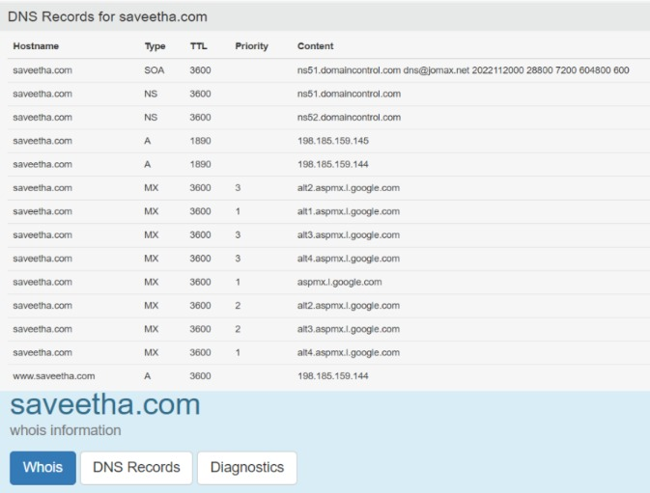
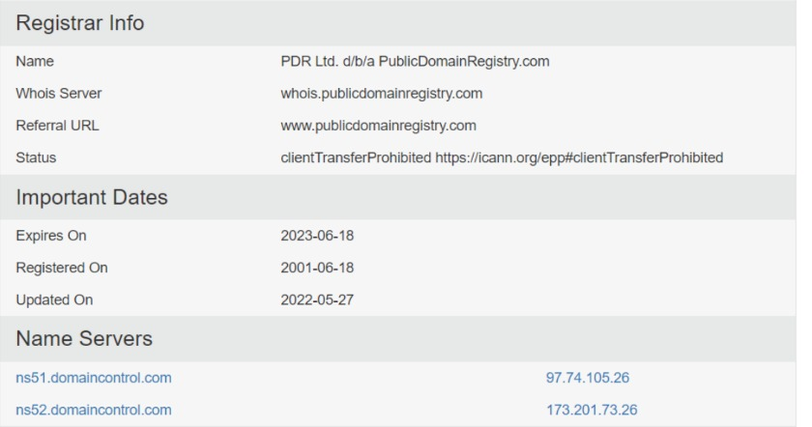
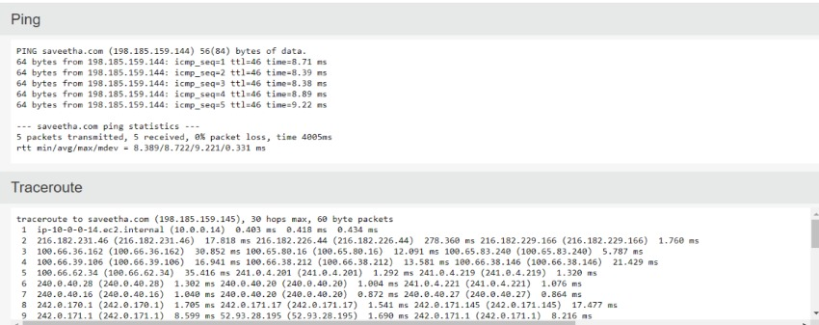

Result
The DNS and WHOIS information for saveetha.com was examined successfully. The screenshots show A, NS, MX, and SOA records, along with registrar and name-server details. The ping output shows 5 packets transmitted and 5 received with 0% packet loss, indicating successful connectivity during the test. The traceroute output displays the network hops toward the destination. These observations demonstrate how DNS lookup, ping, and traceroute can be used to inspect domain configuration and basic network reachability.

